1. 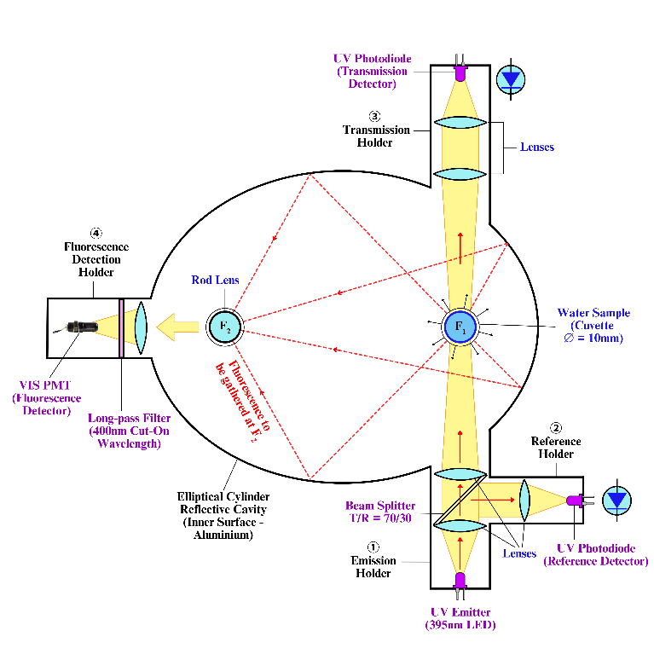**Overall Optical System Design**The proposed optical system can be divided into 5 parts, which are:   
   (1) Elliptical Cylinder Reflective Cavity – Main Body  
   (2) Emission Holder  
   (3) Reference Holder  
   (4) Transmission/Absorption Holder  
   (5) Fluorescence Detection Holder  
     
   (1) The reflective property of an ellipse states that when a ray leaves one of the foci and meets a point on that ellipse, it will reflect off of the ellipse and pass through the other focus. Based on this property, the UV-illuminated water sample (cuvette) is placed at the 1st focal point of the elliptical cylinder cavity, and its isotropically emitted FLU light is (ideally) all concentrated at the 2nd focal point of the reflector. The internal surface of the reflector will be coated with reflective Aluminium materials to enhance reflection.

Figure 1. 2D Representation of Optical System

* + 1. At the **emission holder**, UV LEDs (LZ1-00UBN0) with a typical peak wavelength of 395nm are set up at the end of the holder to emit ultraviolet light to excite fluorescence. Cylindrical lenses are placed in the holder to collimate and focus the UV beam onto the water sample. The beam splitter (70T/30R) splits a portion of the excitation UV beam to the reference holder.
    2. At the **reference holder**, a cylindrical lens is placed to focus the portion of the excitation UV beam onto the reference photodiodes (PDs), which are the same models as the UV LEDs (LZ1-00UBN0).
    3. At the **transmission holder**, another set of cylindrical lenses is used to focus the UV light onto PDs (LZ1-00UBN0) at the end of the transmission holder. PDs detect the UV light transmitted through the sample. The detected signal is subsequently processed together with the reference signal to determine UVA parameter.
    4. At the **fluorescence detection holder**, a long-pass filter with 400nm cut-on wavelength will blocks excitation (ultraviolet wavelength range), allowing only FLU light (visible light wavelength range) to be detected by a photomultiplier tube (PMT)(Hamamatsu H11642-011) after being transmitted from the 2nd focal point of the elliptical reflector. The detected signal will be used to determine FLU parameter.

1. 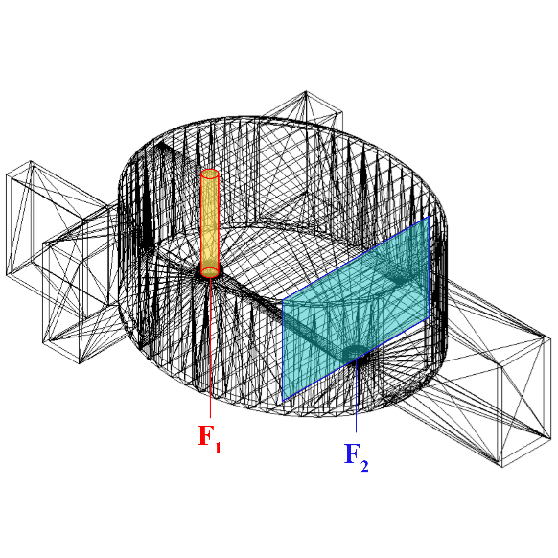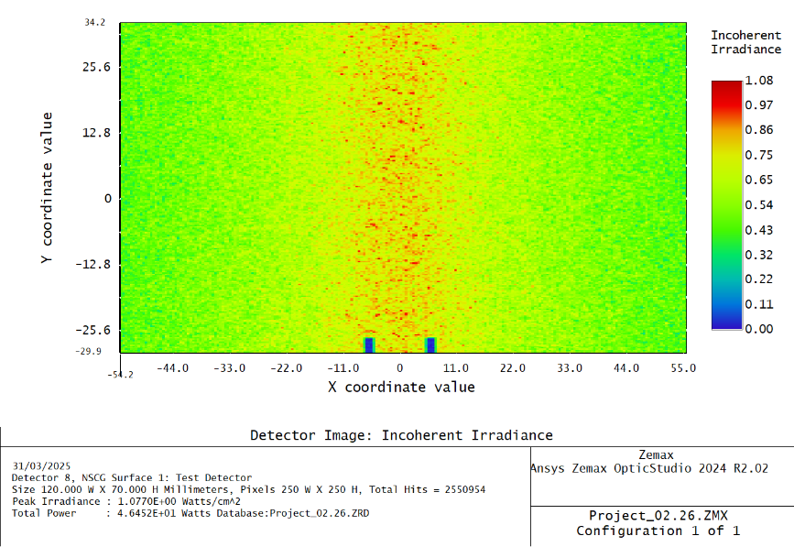**Evaluation of Fluorescence Capturing Performance of the Elliptical Cylinder Reflective Cavity**In Zemax OpticStudio software, Ray Trace and Irradiance Maps were used to simulate and visualize the light distribution.   
     
   After placing a cylindrical light source that emits light rays isotropically at the first focal point (F1) of the ellipse, and a detector (70mm x 110mm) at the second focal point (F2), we performed Zemax ray tracing simulation and obtained the irradiance map. The prominent strip in the center of the image shown in Fig.2 proves that FLU light is gathered effectively at the second focal point of the elliptical reflector.

Figure 2. Irradiance map of FLU light arriving at the 2nd focal point of the reflector

Figure 3. ZEMAX detector for FLU light (blue plane)

This proves that the fluorescence capturing performance suits theory and this elliptical cylinder model is ideal to be used in our design.

1. **Design of the Emission Holder and Transmission Holder**

At the emission and transmission holder, the optimal two-lens combination was determined by using the 1st lens to collimate the UV beam and the 2nd lens to focus it, thereby illuminating the largest cross-sectional area of the water sample to maximize FLU excitation in the sample. The cuvette’s cross-sectional diameter is 10mm. We propose three types of lens combinations and perform iterative optics simulations:

* + - * **Version 1A**: 1 Rod Lens with 2 rows of 5 LEDs
      * **Version 1B**: 1 Rod Lens with 1 row of 10 LEDs
      * **Version 2A**: 2 Rod Lenses with 2 rows of 5 LEDs
      * **Version 2B**: 2 Rod Lenses with 1 row of 10 LEDs
      * **Version 3A**: 2 Cylindrical Convex Lenses with 2 rows of 5 LEDs
      * **Version 3B**: 2 Cylindrical Convex Lenses with 1 row of 10 LEDs

From Version 3B, we fine-tuned the radius of curvature specifications to optimize further and yield Version 4.

* + - * **Version 4**: 2 Cylindrical Convex Lenses with 1 row of 10 LEDs (After Optimization from Version 3B)
      * **Version 5**: Control Set without any Lenses with 1 row of 10 LEDs

All simulation versions are done with 395nm LEDs light sources, beam splitter (25mm x 25mm) and 5 detectors (12mm x 70mm) at different locations:   
Detector 1 – LEDs

Detector 2 – Emission Holder Slit   
Detector 3 – Water Sample

Detector 4 – Transmission Holder Slit

Detector 5 – Photodiodes

**Version 1A: 1 Rod Lens with 2 rows of 5 LEDs**

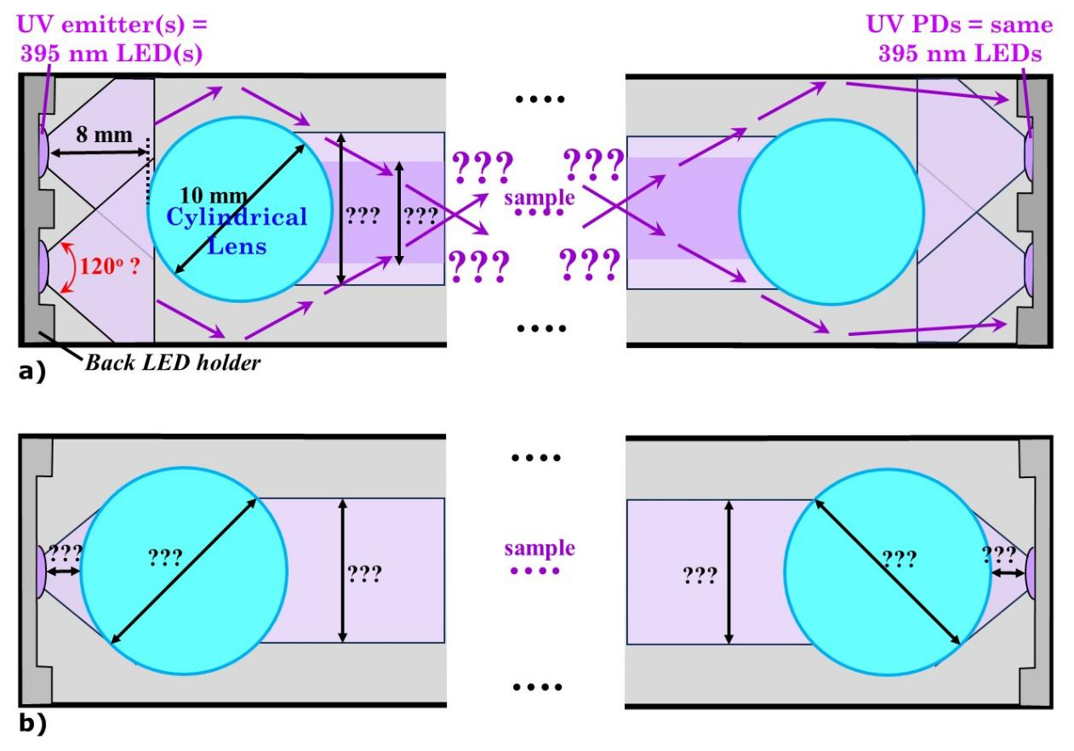

Figure 4. Top view of Version 1A

|  |  |  |  |  |
| --- | --- | --- | --- | --- |
| (1)  LEDs | (2)  Emission Holder Slit | (3)  Water Sample | (4)  Transmission Holder Slit | (5)  Photodiodes |
|  |  |  |  |  |
| Total Power (W) | | | | |
| 10.6980 (100%) | 4.4500 | 2.7305 (25.52%) | 1.9296 | 2.3395 |

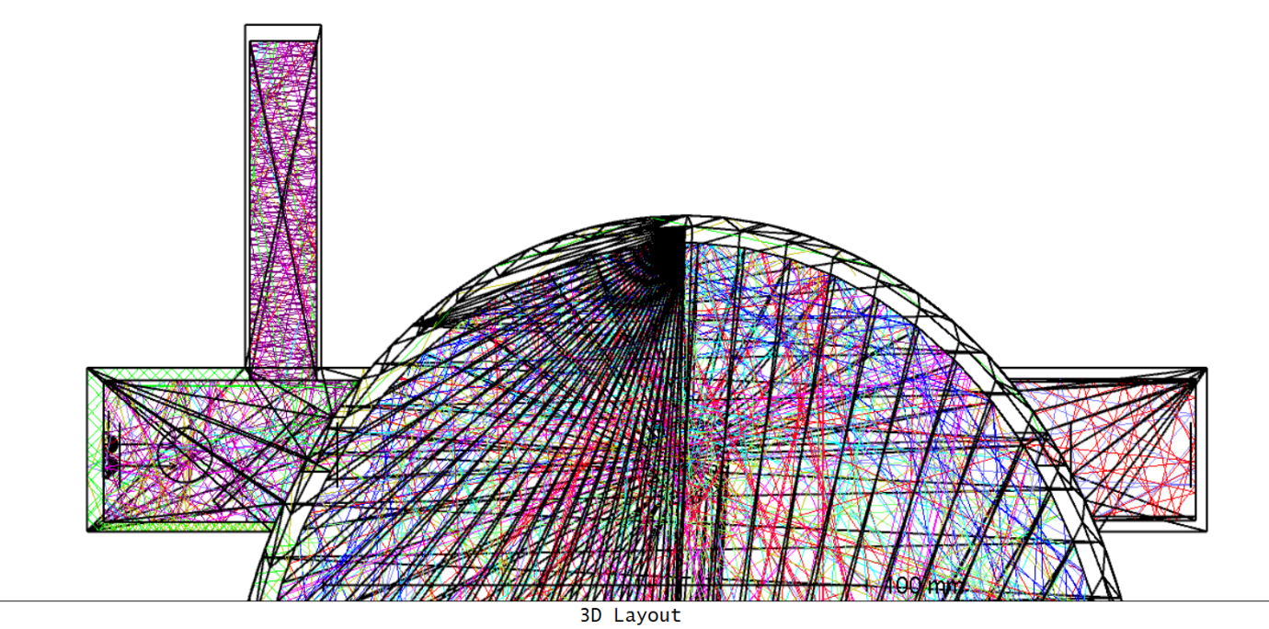

(1)

(2)

(3)

(4)

(5)

Rod Lens   
(Ø10mm)

Beam Splitter

2x5 LEDs

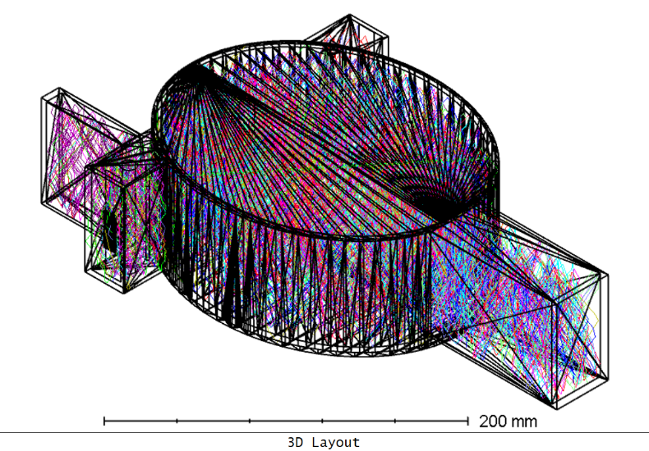

Figure 5. Zemax Optics Simulation of Version 1A

**Version 1B: 1 Rod Lens with 1 row of 10 LEDs**



Figure 6. Top view of Version 1B

|  |  |  |  |  |
| --- | --- | --- | --- | --- |
| (1)  LEDs | (2)  Emission Holder Slit | (3)  Water Sample | (4)  Transmission Holder Slit | (5)  Photodiodes |
|  |  |  |  |  |
| Total Power (W) | | | | |
| 10.3350 (100%) | 4.9643 | 3.0524 (29.53%) | 2.0262 | 2.4648 |

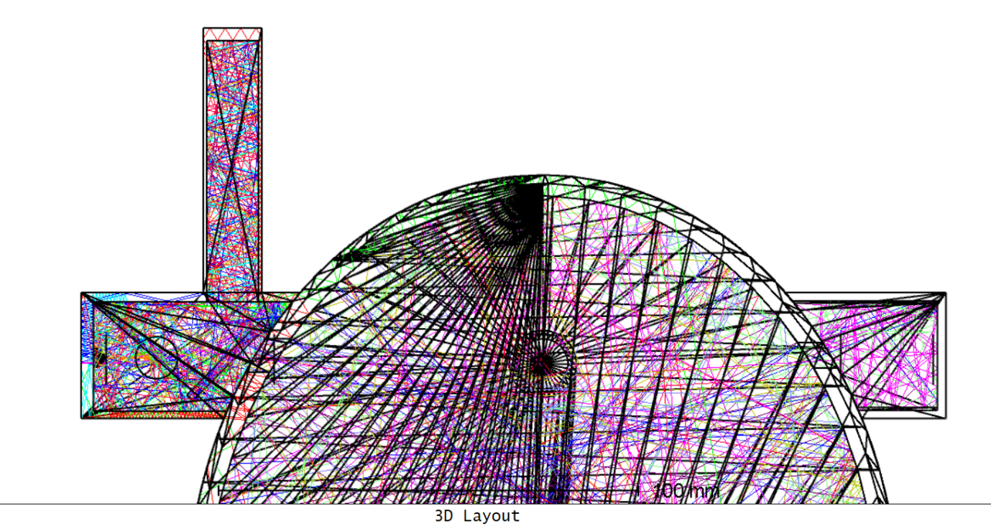

(1)

(2)

(3)

(4)

(5)

Rod Lens   
(Ø10mm)

Beam Splitter

1x10 LEDs

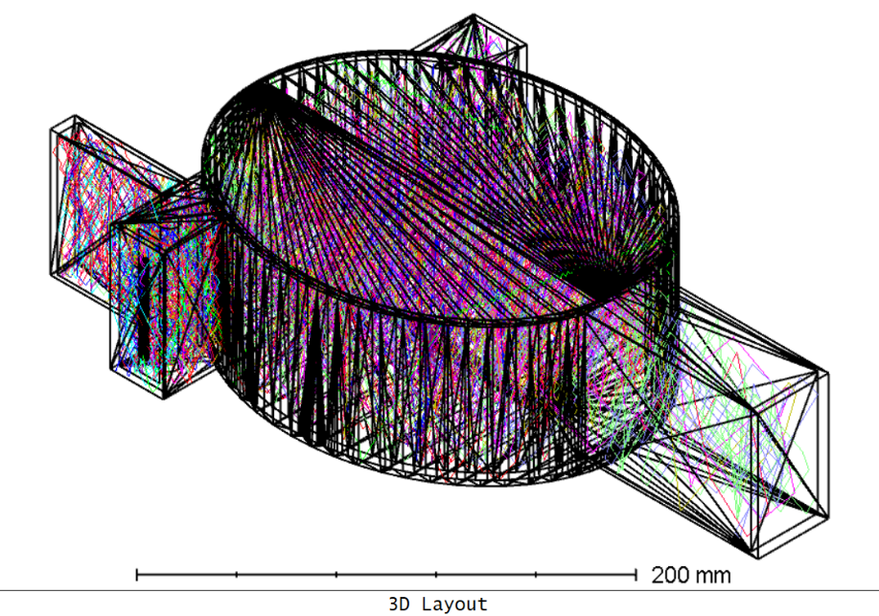

Figure 7. Zemax Optics Simulation of Version 1B

**Version 2A: 2 Rod Lenses with 2 rows of 5 LEDs**

|  |  |  |  |  |
| --- | --- | --- | --- | --- |
| (1)  LEDs | (2)  Emission Holder Slit | (3)  Water Sample | (4)  Transmission Holder Slit | (5)  Photodiodes |
|  |  |  |  |  |
| Total Power (W) | | | | |
| 10.8100 (100%) | 5.7713 | 3.1496 (29.14%) | 2.2209 | 2.6929 |

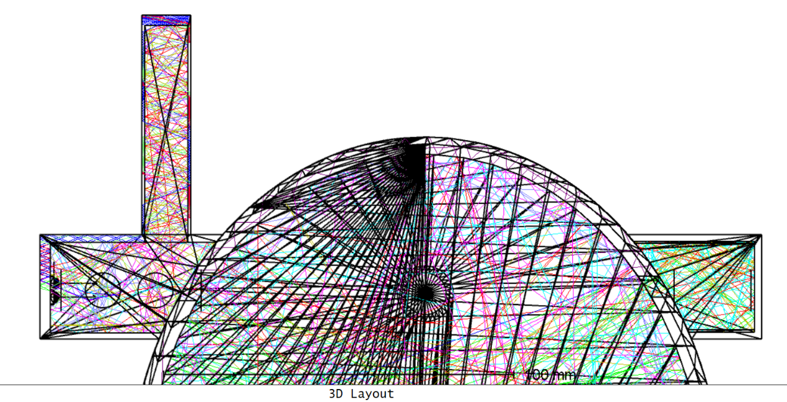

2x5 LEDs

1st Rod Lens   
(Ø10mm)

(1)

(2)

(3)

(4)

(5)

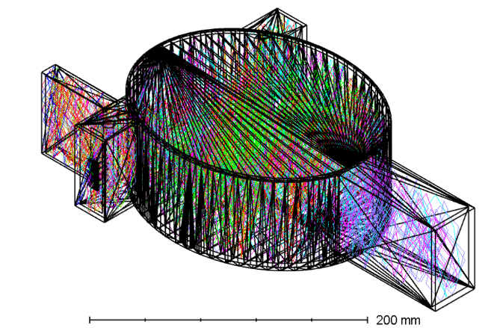

2nd Rod Lens   
(Ø10mm)

Figure 8. Zemax Optics Simulation of Version 2A

**Version 2B: 2 Rod Lenses with 1 row of 10 LEDs**

|  |  |  |  |  |
| --- | --- | --- | --- | --- |
| (1)  LEDs | (2)  Emission Holder Slit | (3)  Water Sample | (4)  Transmission Holder Slit | (5)  Photodiodes |
|  |  |  |  |  |
| Total Power (W) | | | | |
| 10.6290 (100%) | 5.8965 | 4.4750 (42.10%) | 2.4888 | 3.0321 |

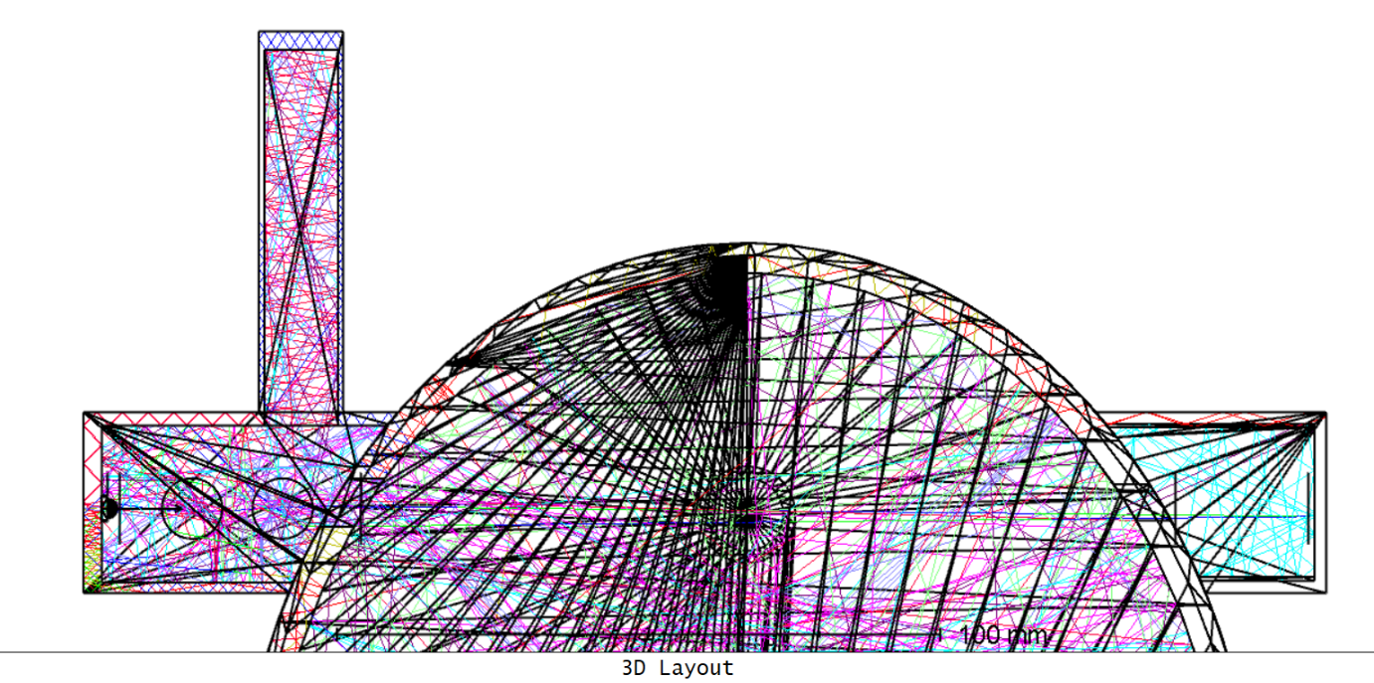

1st Rod Lens   
(Ø10mm)

1x10 LEDs

(1)

(2)

(3)

(4)

(5)

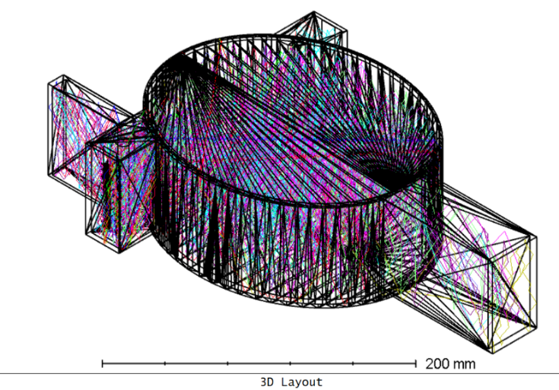

2nd Rod Lens   
(Ø10mm)

Figure 9. Zemax Optics Simulation of Version 2B

**Version 3A: 2 Cylindrical Convex Lenses with 2 rows of 5 LEDs**

For Version 3, we explored a cylindrical convex lens assembly as an alternative to the rod lens. A systematic optimization approach was implemented in Zemax to achieve maximum UV irradiance on the water sample.

The optimal two-lens combination was determined by using the 1st convex lens to collimate the UV beam and the 2nd convex lens to focus it, thereby illuminating the largest cross-sectional area of the water sample to maximize FLU excitation in the sample.

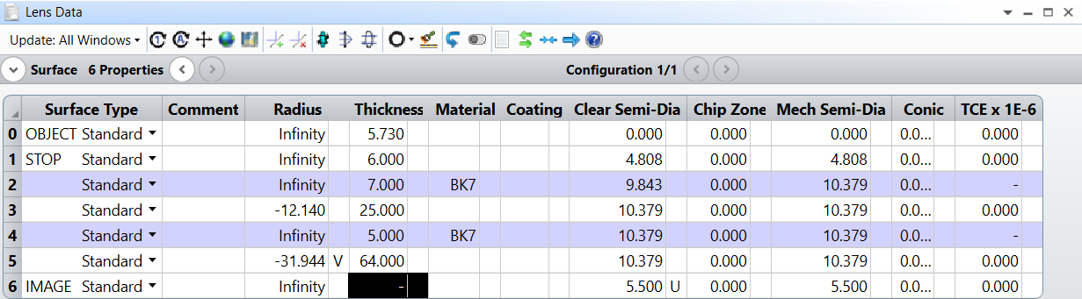   
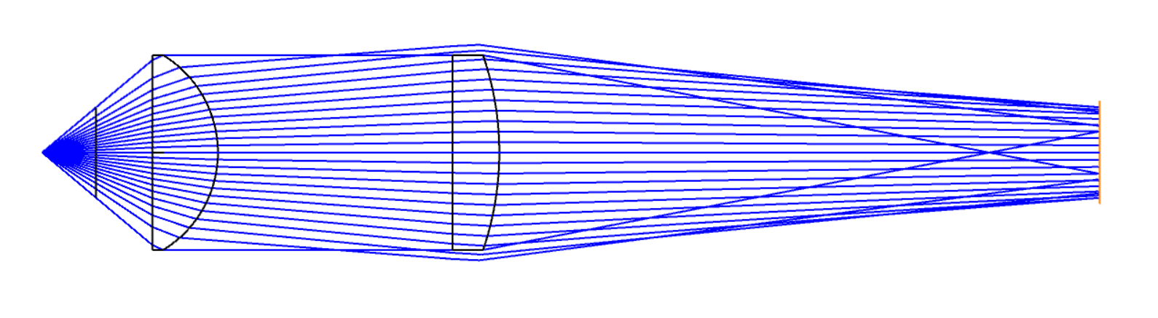

10 mm  
(Water Sample)

Figure 10. Zemax sequential mode simulation for 2 convex lenses

1. **Sequential Mode**

We did a simulation in *sequential mode* to determine the lens specifications and evaluate the focusing performance before importing the lenses to *non-sequential mode* to perform further ray tracing in the reflective cavity.   
  
We modelled a light source (OBJECT) with 80° opening angle. By using Merit Function Editor in the Optimize function and applying the constraint setting of the ‘RANG’ operand (ray angle in radians with respect to the local z-axis of a specified surface) to 0, the system successfully determined the radius of curvature of the first convex lens to collimate the diverging rays.

We then set the second convex lens at 25mm from the back surface of the first convex lens to allocate the placement of the beam splitter which receives the collimated rays. After that, we used Merit Function Editor in the Optimize function so that the system could determine the radius of curvature of the second convex lens to focus the beam to an ideal spot. We then set a 10mm frame (IMAGE) to represent the cross-section of the water sample. After some minor adjustments and finetuning of the radius of curvature of the second convex lens, we set the IMAGE frame to be located at 64mm which is the distance from the emission holder exit slit to the first focal point (F1) of the ellipse while ensuring that the cross-section receives the maximum UV illumination. The lens assembly are ready to be imported into the non-sequential mode to perform ray tracing in the reflective cavity.

Modifications on existing holder design:

* Removed slits at both holders for better focusing performance
* Reduced emission holder length to reduce light waste in the holder

1. **Non-Sequential Mode**

In *non-sequential* *mode*, we imported all the light sources, elliptical reflective cavity modelled from 3D modelling software, beam splitter and lens assembly and placed them at the respective locations determined from *sequential* *mode*. The 5 detectors of the same size are placed at their respective locations.

|  |  |  |  |  |
| --- | --- | --- | --- | --- |
| (1)  LEDs | (2)  Emission Holder Slit | (3)  Water Sample | (4)  Transmission Holder Slit | (5)  Photodiodes |
|  |  |  |  |  |
| Total Power (W) | | | | |
| 9.9871 (100%) | 4.7161 | 3.3823 (33.87%) | 2.5026 | 2.3739 |

Observation shows that there is a vertical line at the middle of detector 3 showing a lower irradiance value, indicating that the light is not focusing and illuminating the water sample ideally as simulated in the *sequential mode*. This might be caused by the usage of 2 rows of 5 LEDs which are misaligned at the principal axis. Hence, we consider Version 3B with 1 row of 10 LEDs.

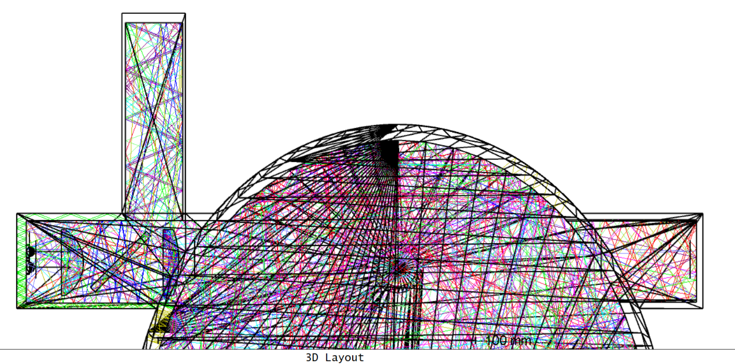

(1)

(2)

(3)

(4)

(5)

Beam   
Splitter

2x5 LEDs

Figure 11. Zemax Optics Simulation of Version 3A

**Version 3B: 2 Cylindrical Convex Lenses with 1 row of 10 LEDs**

|  |  |  |  |  |
| --- | --- | --- | --- | --- |
| (1)  LEDs | (2)  Emission Holder Slit | (3)  Water Sample | (4)  Transmission Holder Slit | (5)  Photodiodes |
|  |  |  |  |  |
| Total Power (W) | | | | |
| 10.1290 (100%) | 4.7962 | 5.2309 (51.64%)) | 4.2985 | 3.9797 |

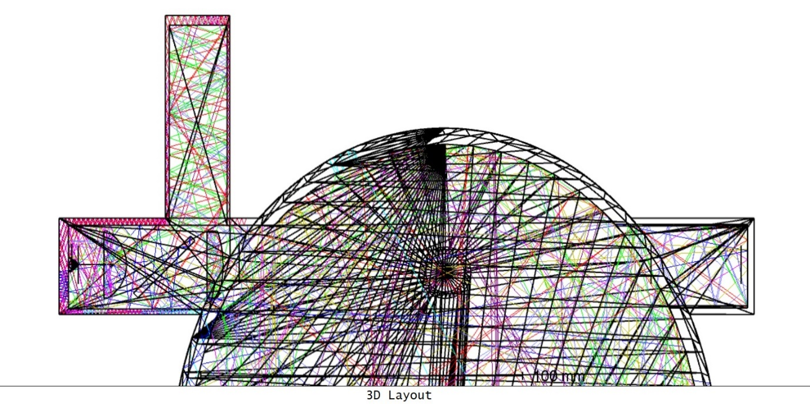

(1)

(2)

(3)

(4)

(5)

Beam   
Splitter

1x10 LEDs

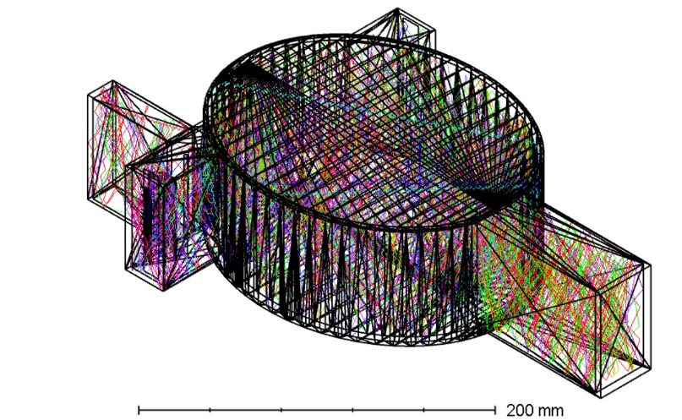

Figure 12. Zemax Optics Simulation of Version 3B

In Version 3B, the focusing performance is improved significantly after changing to 1 row of 10 LEDs because of the alignment in the principal axis which follows the *sequential mode* simulation. Version 3B is chosen for further analysis.   
  
We performed further analysis of the focusing performance of Version 3B in *non-sequential mode* but without the reflective cavity. We placed a large 35mm x 35mm detector at the water sample location and performed a ray tracing.

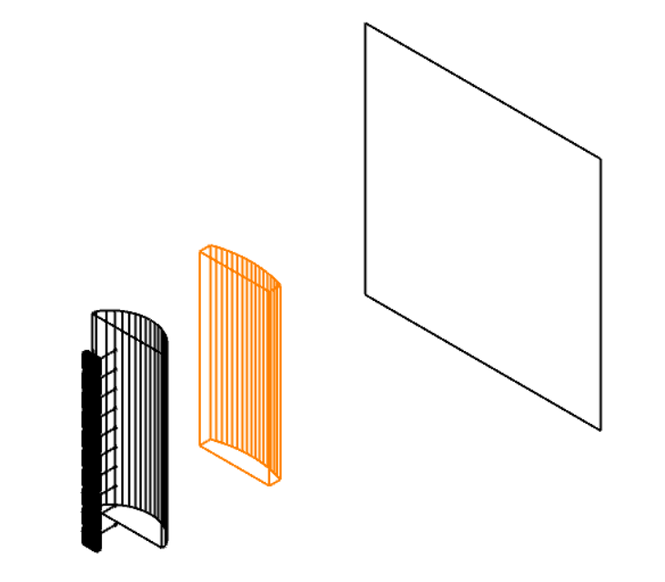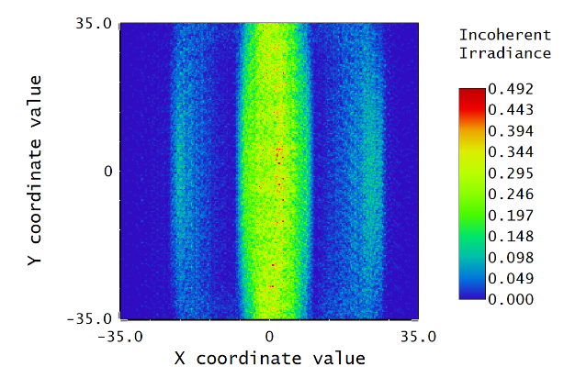

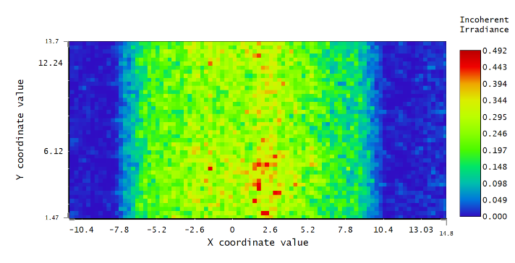

10 mm

Figure 13. Further analysis of Version 3B focusing performance without cavity

We observed an effective focusing performance in Version 3B using 1 row of 10 LEDs. Given the cuvette’s 10mm diameter, most of the UV light successfully illuminated the cross-sectional of the water sample. However, a portion of light (outside white frame) still fell outside the target area and did not illuminate the water sample. To address this, Version 4 introduced further optimization by increasing the radius of curvature of the second convex lens. This adjustment ensured the prominent strip of UV light distribution matched the 10mm width of the cuvette, thereby maximizing illumination onto the water sample.

**Version 4: 2 Cylindrical Convex Lenses with 1 row of 10 LED   
(After Optimization from Version 3B)**In *non-sequential mode*, we performed iterative simulation by fine-tuning and increasing the radius of curvature of the second convex lens to achieve the highest UV irradiance power at the water sample detector, which is improved from 51.64% to 57.54%. This is the final optimized specification of the lenses we have determined:

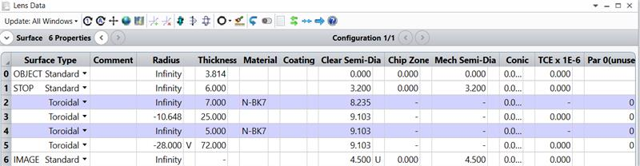

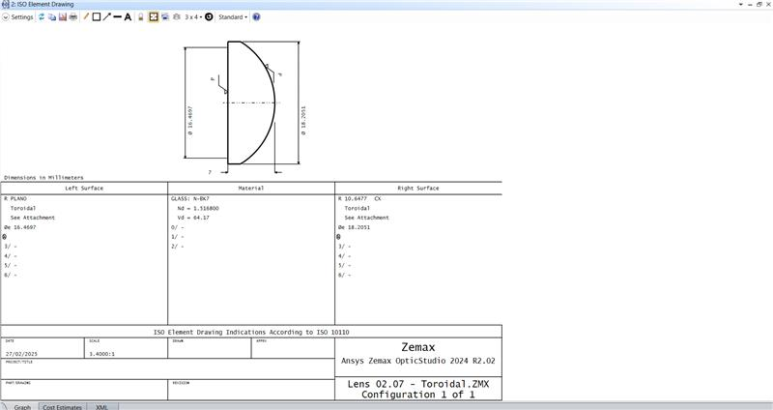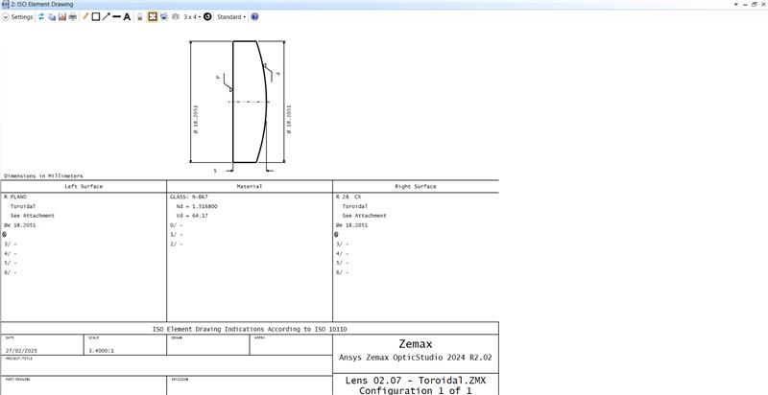

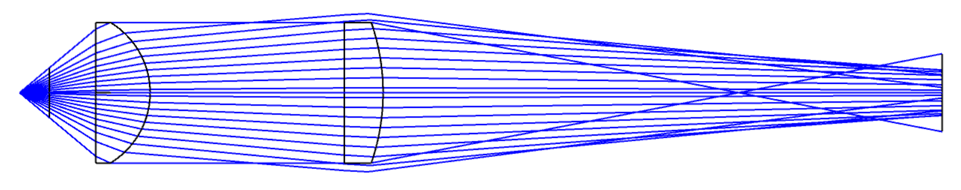

Figure 14. Zemax sequential mode simulation for Version 4 – after optimization from Version 3B

10 mm  
(Water Sample)

|  |  |  |  |  |
| --- | --- | --- | --- | --- |
| (1)  LEDs | (2)  Emission Holder Slit | (3)  Water Sample | (4)  Transmission Holder Slit | (5)  Photodiodes |
|  |  |  |  |  |
| Total Power (W) | | | | |
| 9.9879 (100%) | 4.9360 | 5.7470 (57.54%) | 4.1993 | 3.8277 |

**Version 5: Control Set without any Lenses with 1 Row of 10 LEDs**

|  |  |  |  |  |
| --- | --- | --- | --- | --- |
| (1)  LEDs | (2)  Emission Holder Slit | (3)  Water Sample | (4)  Transmission Holder Slit | (5)  Photodiodes |
|  |  |  |  |  |
| Total Power (W) | | | | |
| 11.484 (100%) | 6.7681 | 4.5936 (40%) | 4.9811 | 4.8360 |

After comparison with Version 5, which is a control set without any lenses with 1 row of 10 LEDs, the power irradiance onto the water sample has improved from 40% to 57.54% with the usage of the 2 cylindrical convex lenses in Version 4.

Hence, **Version 4** with the optimized 2 cylindrical convex lenses was ultimately selected for implementation. The same lens assembly was applied to both the emission and transmission holders in a symmetrical configuration. This approach was based on the assumption that we neglect the significant effect of scattering and refraction, such that the optical path for the transmission holder is optically reversible relative to that of the emission holder.

1. **Design of the Reference Holder**

Assuming that the incident light reflected by the beam splitter toward the reference holder is collimated, we can utilize the same first cylindrical convex lens used in the emission holder to focus the light onto the end of the reference holder where the photodiodes are positioned. This is valid provided that the distance from the lens to the end of the reference holder is identical to that in the emission holder, which shows symmetrical optical focusing behaviour.   
  
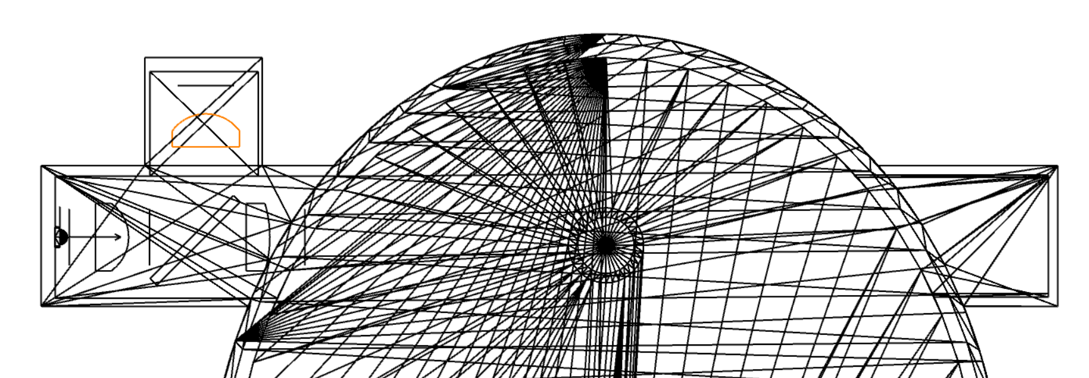

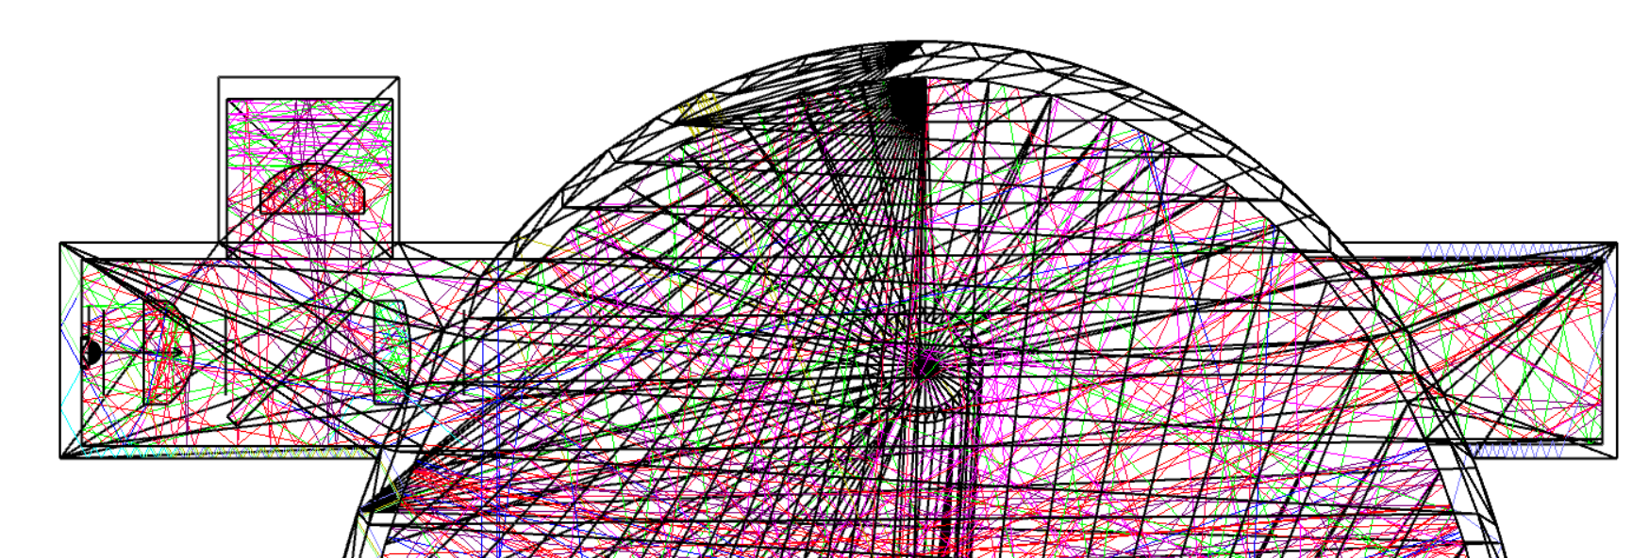

Figure 15. Top view of the lens placement in reference holder

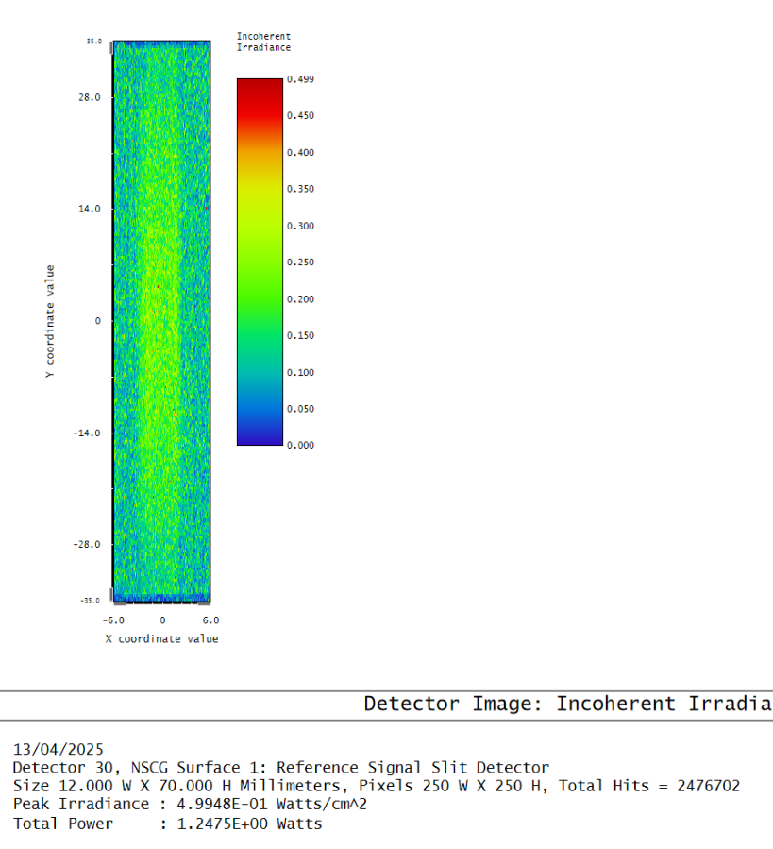

Figure 16. Irradiance map of detector at end of reference holder

The prominent strips show that the same first cylindrical convex lens used in the emission holder can focus the light onto the end of the reference holder effectively.

1. **Design of the Fluorescence Detection Holder**

We proposed using a rod lens at the 2nd focal point of the elliptical reflective cavity to collimate the fluorescence light reflected from the surface after being emitted from the UV-illuminated water sample at the 1st focal point.

Below is the simulation done in Zemax *sequential mode*, showing that fluorescence light can be channelled to the fluorescence detection holder with a rod lens placed at the 2nd focal point (slightly shifted with F2 at the rightmost edge of the rod lens), by accepting the fluorescence light that arrives at the 2nd focal point with a large incidence angle.

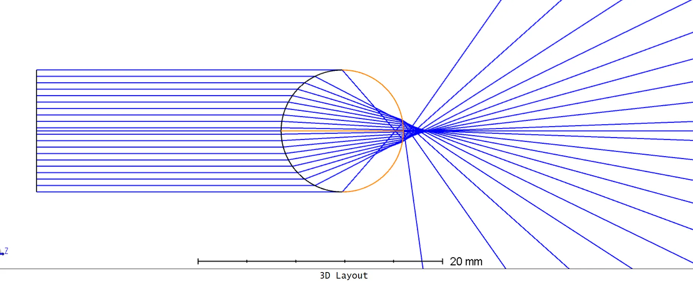

Figure 11. Zemax sequential mode simulation for fluorescence collimation with a rod lens placed at 2nd focal point

In Zemax *non-sequential mode*, we performed ray tracing simulation with different versions to examine the performance of the rod lens.

**Version A: Control Set without any Lenses (40mm x 70mm detector at holder entrance)**

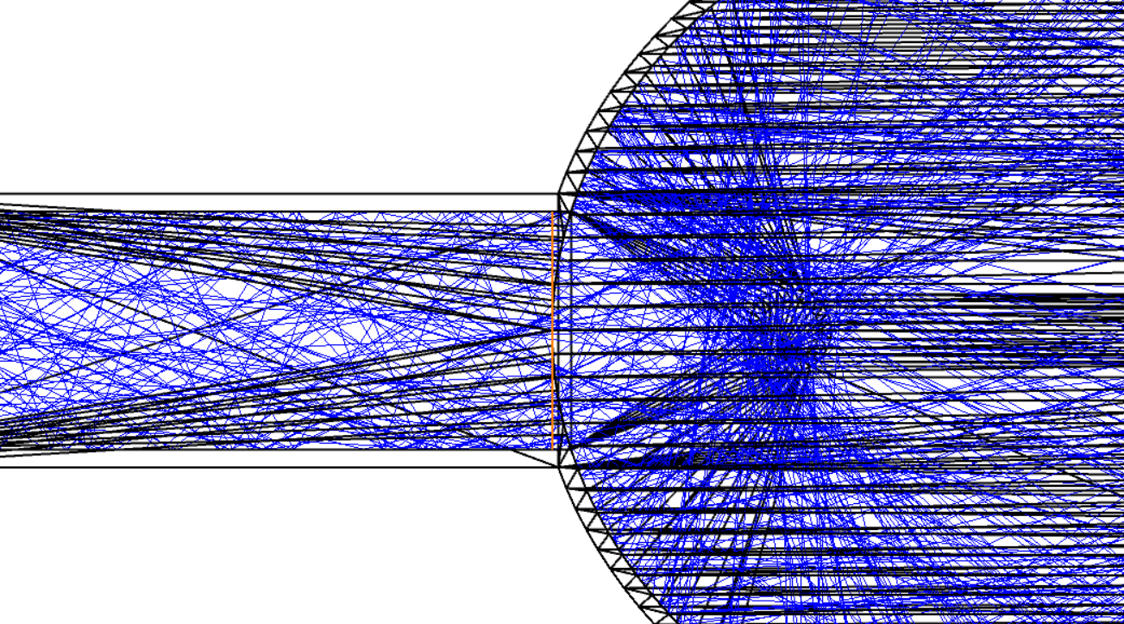 

Total Power: 2.2396

**Version B: Rod Lens placed at F2 (40mm x 70mm detector at holder entrance)**

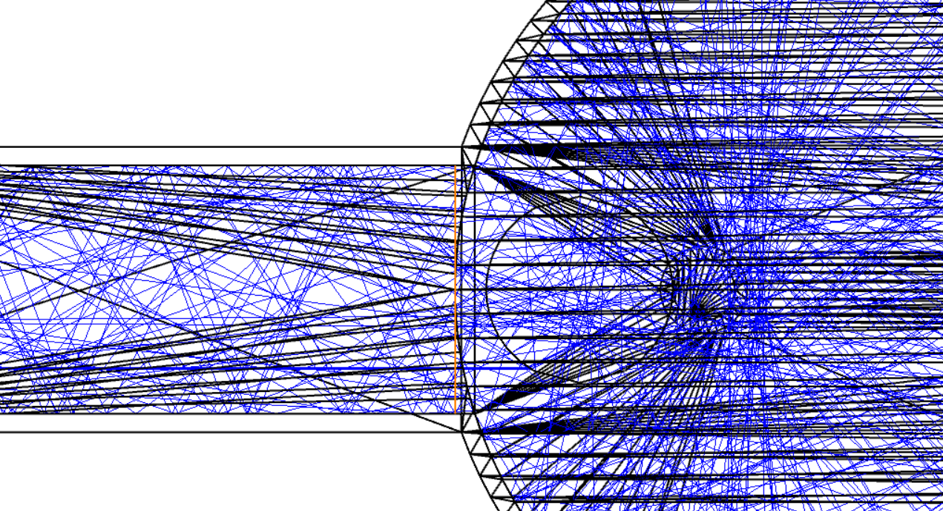 

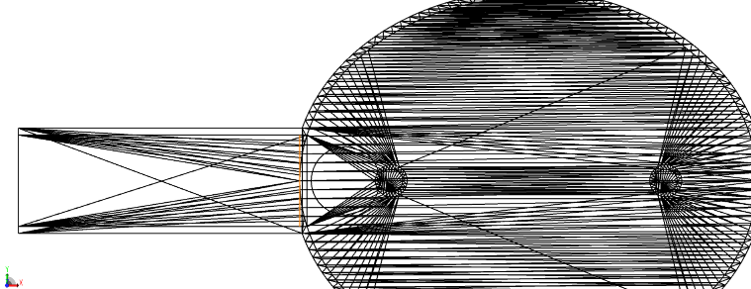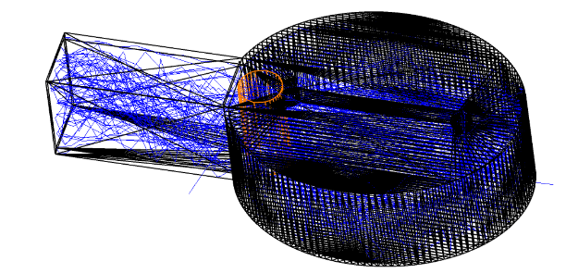

Total Power: 1.1216

With the rod lens placed inside the reflective cavity at F2, we observed that the fluorescence light emitted from the water sample at F1 is focused through the central region of the detector which covers the cross-section of the fluorescence detection holder. However, the total power computed over this area was lower compared to the control set in Version 1.

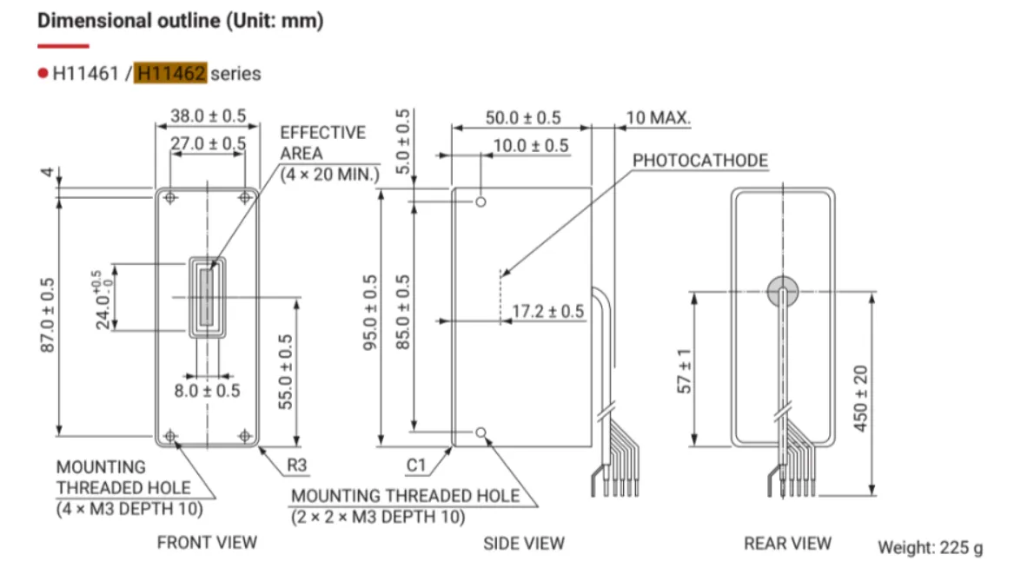

To further investigate this discrepancy, we examined detector size matching the effective detection area of the photomultiplier tube module (PMT), specifically 4mm x 22mm, to evaluate more specific cases of fluorescence capturing performance.

**Version 1: Control Set without any Lenses (4mm x 22mm detector at F2)**

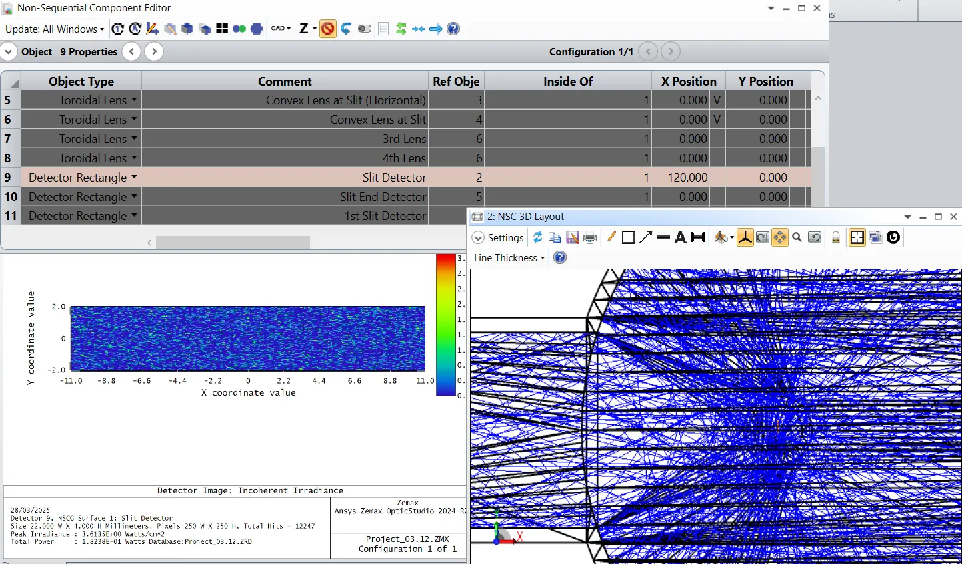

Total Power: 1.8238E-01

**Version 2: Control Set without any Lenses (4mm x 22mm detector at holder entrance)**

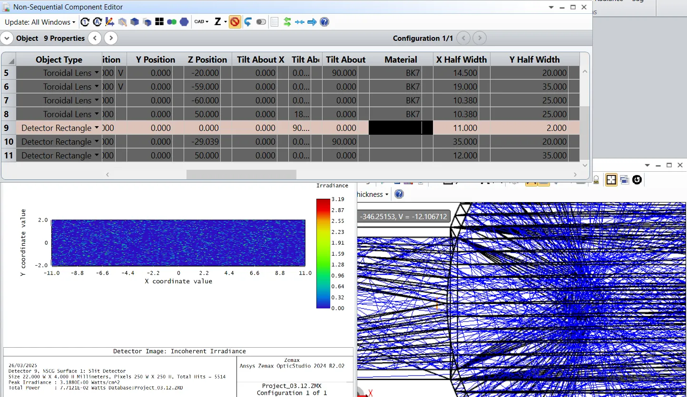

Total Power: 7.7121E-02

**Version 3: Rod Lens placed at F2 (4mm x 22mm detector at holder entrance)**

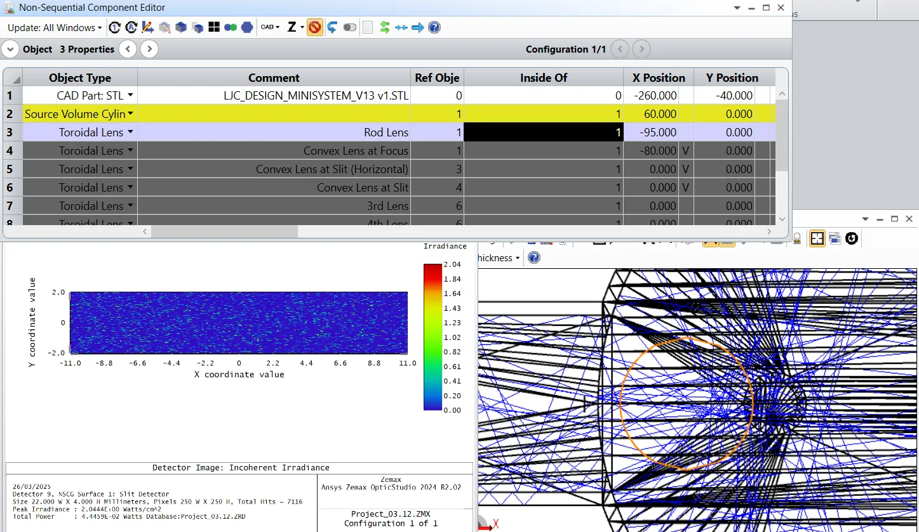

Total Power: 4.4459E-02

In Version 3, where the rod lens is placed at F2, the expected focusing behaviour was not observed when using a small detector positioned at the center of the holder’s cross-section. The total power computed within this region remained lower than that of the control set using a detector of the same size. As such, the current results do not justify the use of a rod lens for fluorescence collection, and we might need to find another method to effectively channel the fluorescence captured at F2 to the PMT.   
  
However, our previous simulations conducted in *sequential mode* indicated that a rod lens should theoretically be capable of collimating fluorescence rays with large incident angles. This discrepancy led us to suspect potential issues with Zemax’s *non-sequential ray tracing*. Specifically, we observed that Zemax prematurely ends each ray-tracing cycle within a short duration, which may result in incomplete or aborted simulations, especially when generating irradiance maps. This might be due to limited computing power of the used device, and this could also explain the underestimation of collected power in the current analysis. We planned to perform similar ray tracing in another optical design software, such as 3D Optix or TracePro to verify the performance of the rod lens again.



Arranged by: Loh Jing Chen U2320040E EEE/Y2 URECA Student  
Updated on: 12 April 2025